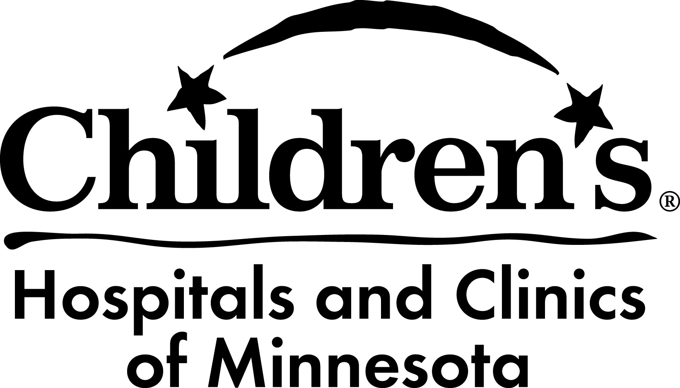
MN Perinatal HIV Program | Delivery Plan
Plan Date: Update:

*Confidentiality surrounding patient’s diagnosis is very important. Please discuss HIV diagnosis/treatment with her alone and establish to whom, if anyone, she has disclosed her HIV status. Additional NOTE:

Name: |  |  |  |  |  |  | DOB: |  |  |  | Due Date:
Planned Mode of Delivery: |  |  | Vaginal: Spontaneous labor Vaginal: Induction date/time: a
 |  |  | C-Section date/time: a
Hospital Planned for Delivery:
OB/GYN Physician: |  |  |  |  |  | Phone: |  |  |  | Other:
ID Physician: |  |  |  |  |  | Phone: |  |  |  | Other:
Current HIV Medications & Dosing:
Recent Lab Results
Date
Viral Load
CD4 count (T-cell)

Standard Maternal Medications for Delivery:
- If Viral Load <1000 copies/mL: Oral HIV medications as prescribed. IV Zidovudine (AZT, ZDV) not required.
- If Viral Load >1000 copies/mL: Oral HIV medications as prescribed. IV Zidovudine (AZT, ZDV) recommended.

Patient and Provider Decision:
Do not use IV Zidovudine (AZT, ZDV)
Use IV Zidovudine (AZT, ZDV)

Zidovudine (AZT, ZDV) 2mg/kg IV loading dose over an hour, then 1 mg/kg/hr continuous infusion until delivery. (Goal: minimum of 3 hrs before delivery, no max time limit.) If on Combivir: hold Combivir during IV AZT administration, give Lamivudine 150 mg bid.

Additional medications/orders:

Newborn Medications: | Zidovudine (ZDV, AZT) syrup 4mg/kg po q 12 hrs beginning as soon as possible and definitely by 6-12 hrs of age, continuing for a total of 6 weeks. (Dose adjustments are warranted for premature infants less than 35 weeks gestation, or if any IV therapy is needed. Please contact pediatric ID consultation for adjusted orders if needed.)

Additional medications/orders: |  |  | FORMULA FEEDING ONLY.
NOTE: Please discharge pt with at least 2 wks+ pediatric syrup; it is not easily available at community pharmacies. Infant will need to complete full 6£ weeks of Zidovudine.
£ Recommend any changes to length of ZDV treatment be determined by a pediatric infectious disease specialist, experienced in HIV, within the first weeks of life.
Community Pharmacy (if needed):
Newborn Labs at Birth: |  | CBC with diff and plts
Newborn Follow-up:
2 week HIV PCR screening |  | Pediatric ID clinic: |  |  |  | Phone:
Well Child Care |  | Clinic: |  |  |  | Phone:
NOTE: Please call the Perinatal Nurse Coordinator following delivery to help arrange for HIV screening apts.
For consultation: Please contact Dr. Laura Hoyt, Pediatric ID Consultant, Children’s Hospitals & Clinics of MN
 | Physician Access Line: |  |  | 612-343-2121 | Natl. Perinatal Hotline: 1-888-448-8765
**Please FAX mom’s L&D records & newborn’s nursery record to the Perinatal HIV Nurse Coordinator for follow-up, including mandatory state reporting, at 651-220-7233

